**ASSIGNMENT-4**

**DISTANCE DETECTION USING ULTRASONIC SENSOR**

|  |  |
| --- | --- |
| Date | 20 October 2022 |
| Team ID | PNT2022TMID44982 |
| Name | Dayana p |
| Student Roll Number | 811219106001 |
| Maximum Marks | 2 Marks |

Question1 :

Write code and connections in wokwi for ultrasonic sensor. Whenever distance is less than 100 cms send "alert" to ibm cloud and display in device recent events.

WOKWI LINK :

https://wokwi.com/projects/305566932847821378

CODE :

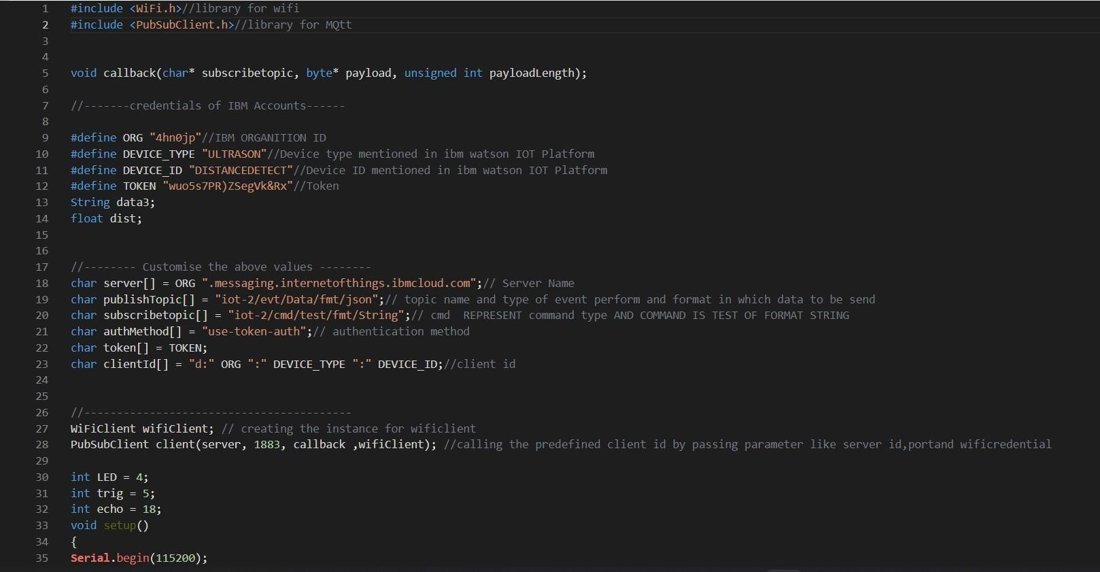

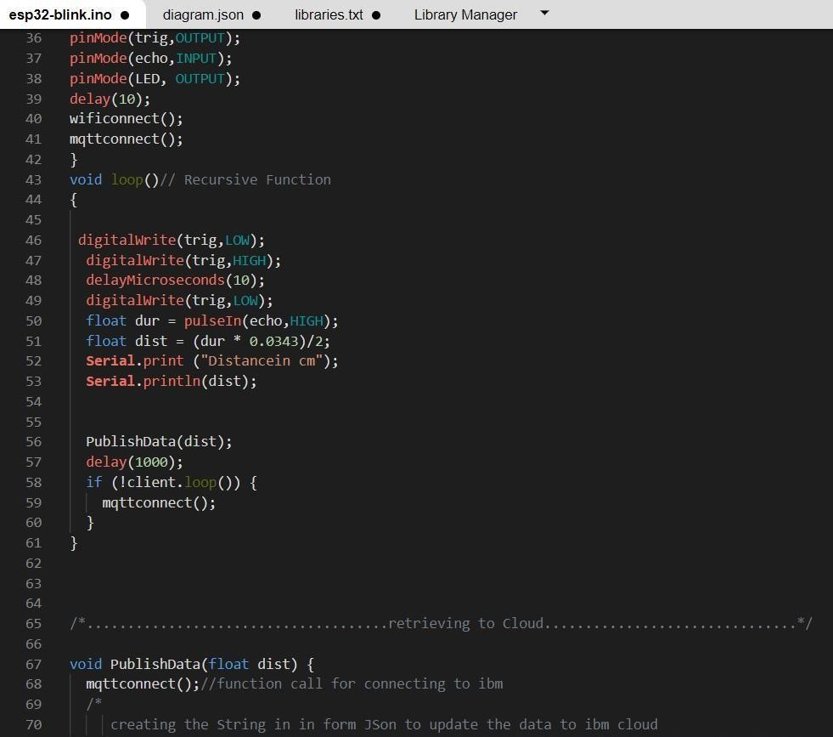

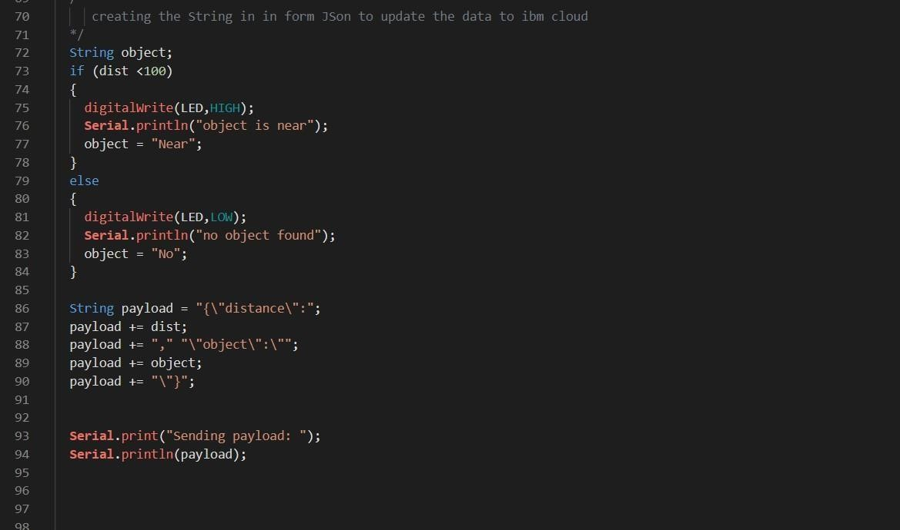

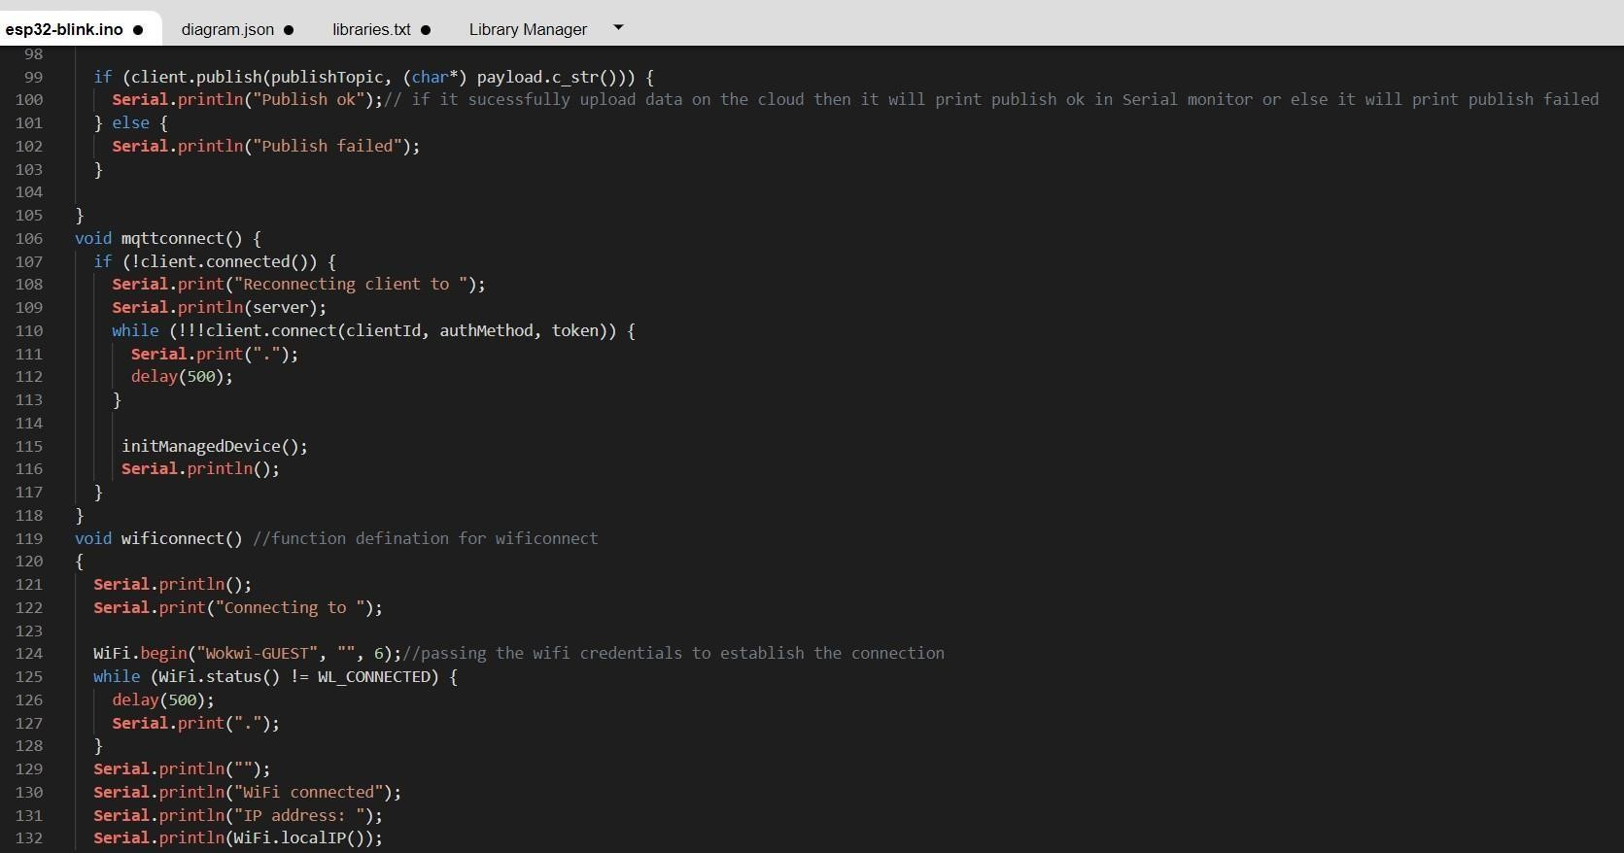

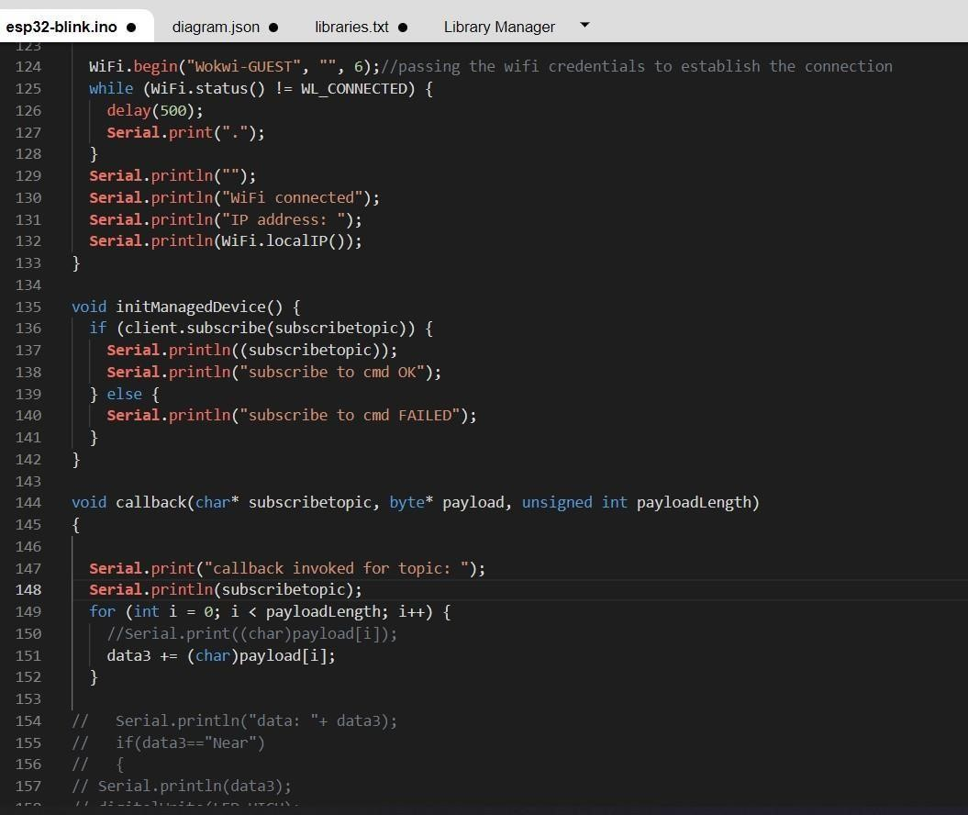

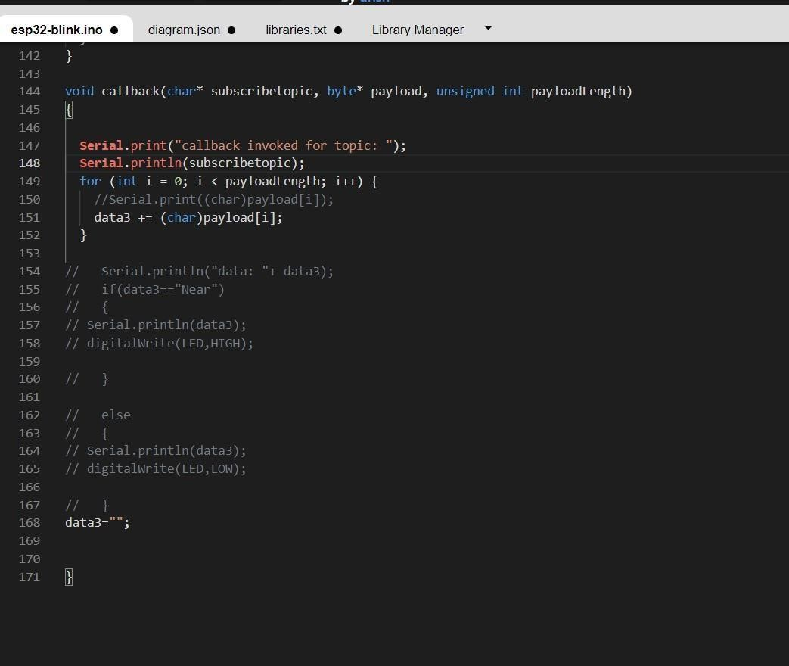

OUTPUT:

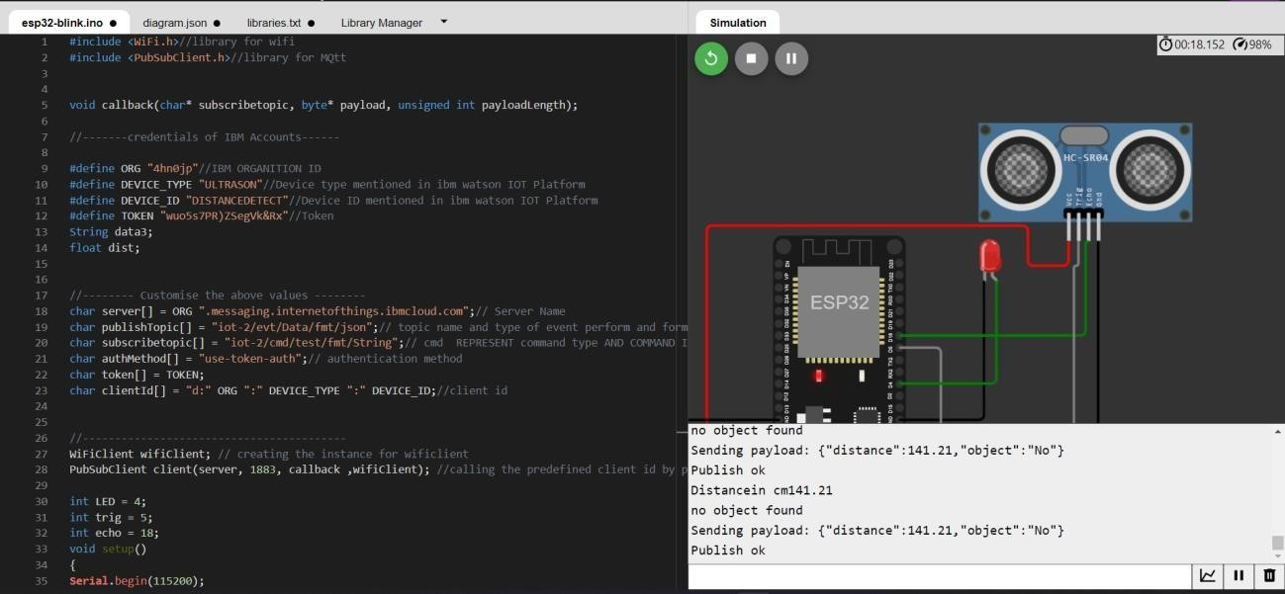

# Data send to the IBM cloud device when the object is far

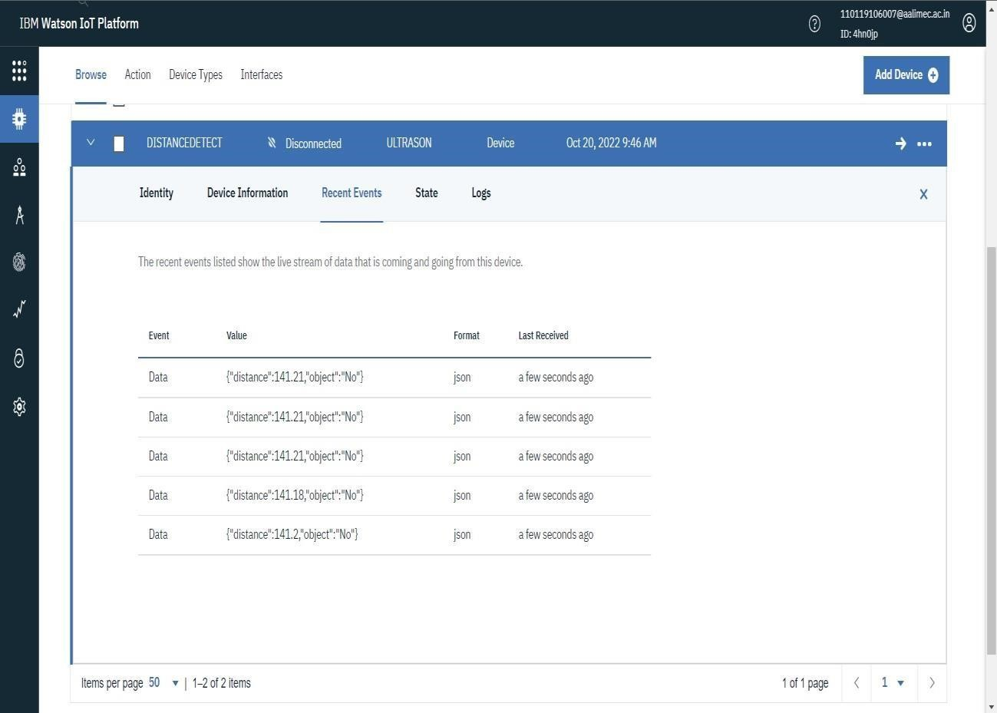

# when object is near to the ultrasonic sensor

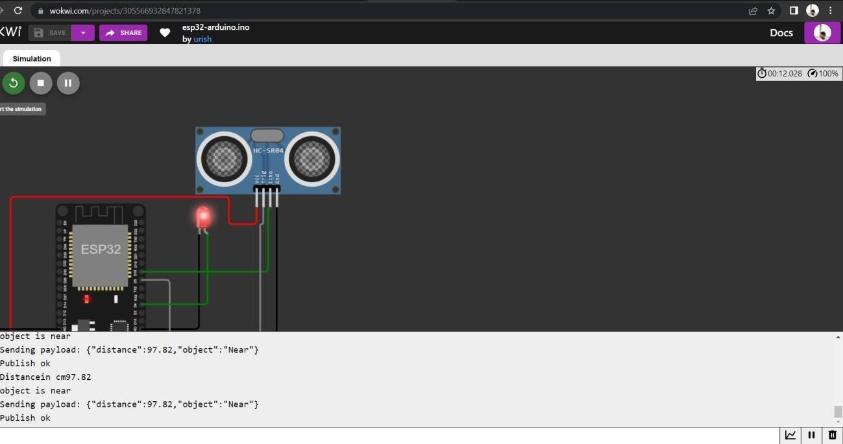

# Data sent to the IBM Cloud Device when the object is near

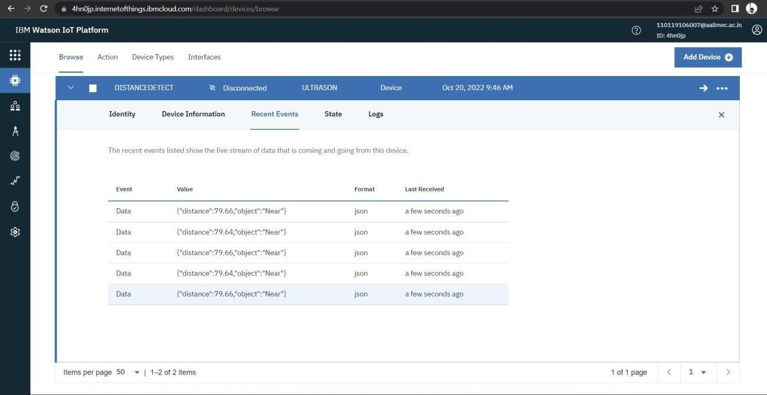

# https://wokwi.com/projects/305566932847821378